Lab: Create an MCP Server
for an AI Service Desk
Beginner-friendly hands-on lab — GitHub Copilot + Python + MCP

Objective
In this lab, you will build a very small, simple server using a technology called MCP (Model Context Protocol). Think of MCP as a bridge that lets GitHub Copilot ask your own Python code to do things — like searching for help articles or creating a support ticket — instead of just guessing an answer.
By the end, you will have a working “AI Service Desk” that Copilot can talk to, right inside VS Code.

What you will be able to do
- Build a small MCP server using Python
- Turn a normal Python function into a tool Copilot can use
- Connect that server to GitHub Copilot in VS Code
- Ask Copilot a question and watch it choose and run the right tool
- Understand, in simple terms, how an AI agent uses outside tools
Estimated time: 20–25 minutes

Before You Start
Make sure you have the following ready:
What You Need | Why
Windows 10/11 | The environment this lab was built for
VS Code | Where you'll write code and use Copilot
Python 3.12 | Runs the MCP server
GitHub Copilot | The AI assistant that will use your tools
Copilot Agent Mode | Lets Copilot actually run the tools

Good to know
You do NOT need Azure Functions, Azurite, Azure Storage, or "func start" for this lab. Everything runs locally on your computer.

How It All Fits Together
Before you start typing commands, here's the big picture. When you ask a question, it travels through a few simple hand-offs before you get an answer:
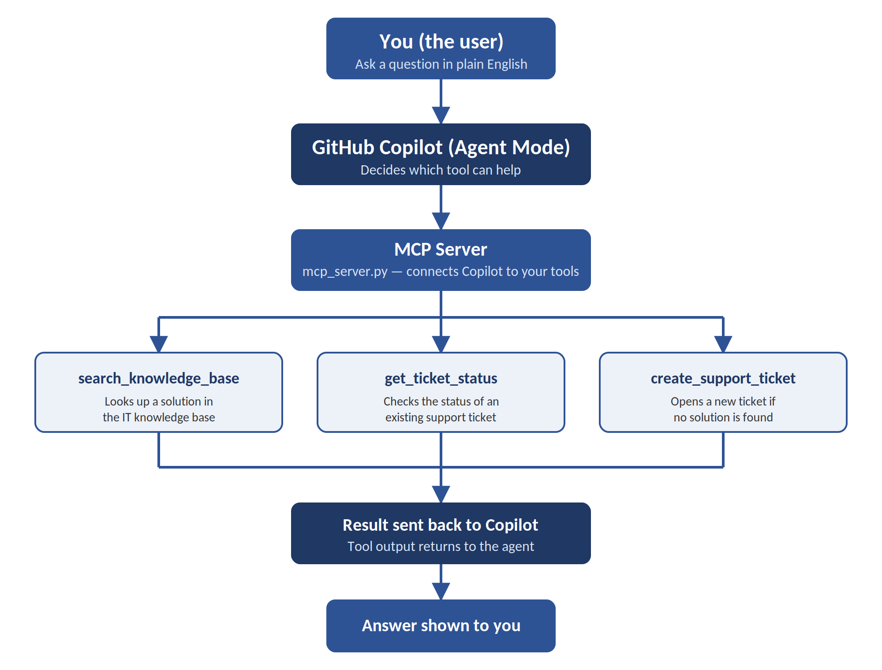
In plain words: you ask a question → Copilot decides which tool fits → the MCP server runs that tool → the answer travels back up to you. You never talk to the tools directly — Copilot does that for you.

Instructions
Follow the steps below in order. Each step builds on the one before it.

Step 1 — Make a Project Folder
Every lab needs its own folder so files don't get mixed up. Let's make one.
Open PowerShell.
mkdir AI200-MCP-Lab
cd AI200-MCP-Lab
Open the folder in VS Code:
code .

Step 2 — Set Up Python
We'll create a clean, separate Python environment just for this lab, so it doesn't affect anything else on your computer.
Check which Python versions you have:
py --list
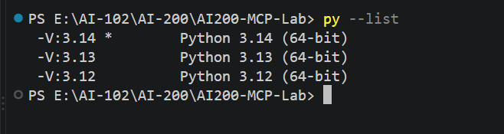
You should see Python 3.12 in the list. Now create the environment:
py -3.12 -m venv labenv

Turn it on (activate it):
.\labenv\Scripts\Activate.ps1
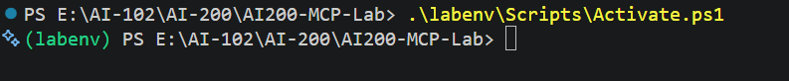
Your terminal line should now start with (labenv). Double-check the version:
python --version
You should see: Python 3.12.x
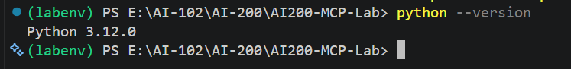

Step 3 — Plan Your Files
This lab only needs a few simple files. Nothing extra, nothing complicated.
You'll end up with this structure:
AI200-MCP-Lab
│
├── labenv
├── mcp_server.py
├── requirements.txt
└── .vscode
└── mcp.json

Step 4 — List What You Need (requirements.txt)
This file just tells Python which package to install.
Create a file named requirements.txt and add this one line:
mcp[cli]
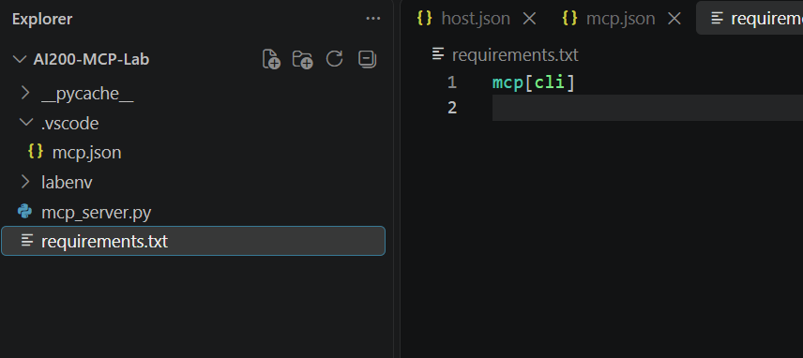
Now install it:
pip install -r requirements.txt
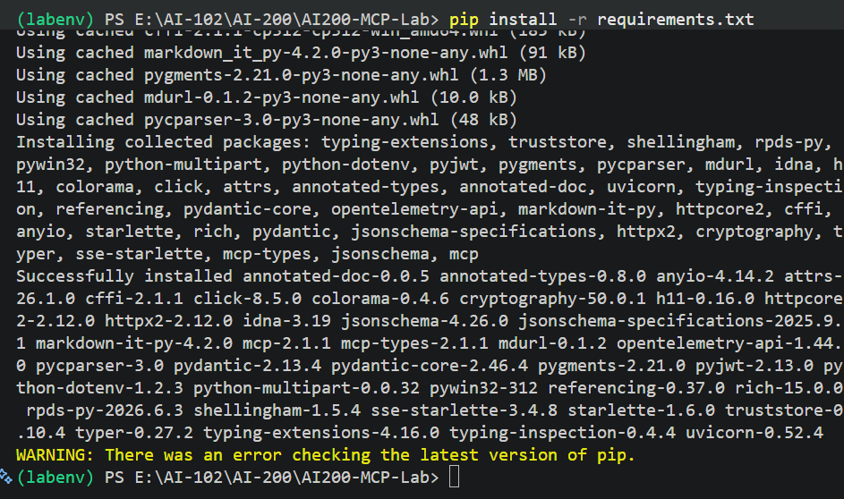
Check that it installed correctly:
python -c "from mcp.server.mcpserver import MCPServer; print('MCP SDK v2 OK')"
You should see: MCP SDK v2 OK
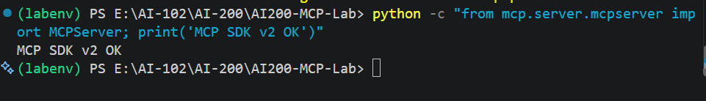

Step 5 — Build the MCP Server
Now for the main part. We'll create a small Python file that offers three simple "tools" Copilot can use: search for help, check a ticket, and create a ticket.
Create mcp_server.py and paste in this code:
from mcp.server.mcpserver import MCPServer

# ---------------------------------------------------------
# Create MCP Server
# ---------------------------------------------------------

mcp = MCPServer("AI Service Desk")

# ---------------------------------------------------------
# Knowledge Base
# ---------------------------------------------------------

KNOWLEDGE_BASE = {
"vpn": {
"title": "VPN Connection Problems",
"solution": (
"If the company VPN is not connecting, first verify "
"your internet connection. Restart the VPN client and "
"try connecting again. If the problem continues, "
"restart the laptop and retry."
)
},

"password": {
"title": "Password Reset",
"solution": (
"Use the company password reset portal to change "
"your password. After resetting it, sign in again "
"to the required applications."
)
},

"laptop": {
"title": "Laptop Performance",
"solution": (
"Restart the laptop, close unnecessary applications, "
"and check available disk space."
)
}
}

# ---------------------------------------------------------
# MCP Tool
# ---------------------------------------------------------

@mcp.tool()
def search_knowledge_base(query: str) -> str:
"""
Search the IT knowledge base for common support problems.
"""

query = query.lower()

for keyword, article in KNOWLEDGE_BASE.items():

if keyword in query:

return (
f"Knowledge Base Article: {article['title']}\n\n"
f"Recommended Solution:\n"
f"{article['solution']}"
)

return (
"No matching knowledge-base article was found. "
"Please create a support ticket for further assistance."
)

# ---------------------------------------------------------
# MCP Tool - Ticket Status
# ---------------------------------------------------------

@mcp.tool()
def get_ticket_status(ticket_id: str) -> str:
"""
Get the status of an IT support ticket.
"""

tickets = {
"T1001": {
"status": "In Progress",
"team": "Network Team",
"message": "Network team is investigating the VPN issue."
},
"T1002": {
"status": "Resolved",
"team": "Identity Team",
"message": "Password reset request has been completed."
},
"T1003": {
"status": "Waiting for Approval",
"team": "Endpoint Team",
"message": "Laptop replacement request is awaiting approval."
}
}

ticket = tickets.get(ticket_id.upper())

if not ticket:
return f"Ticket {ticket_id} was not found."

return (
f"Ticket ID: {ticket_id.upper()}\n"
f"Status: {ticket['status']}\n"
f"Assigned Team: {ticket['team']}\n"
f"Details: {ticket['message']}"
)

# ---------------------------------------------------------
# MCP Tool - Create Ticket
# ---------------------------------------------------------

@mcp.tool()
def create_support_ticket(
issue: str,
priority: str = "Medium"
) -> str:
"""
Create a simple IT support ticket.
"""

ticket_id = "T2001"

return (
f"Support ticket created successfully.\n\n"
f"Ticket ID: {ticket_id}\n"
f"Priority: {priority}\n"
f"Issue: {issue}"
)

# ---------------------------------------------------------
# Start MCP Server
# ---------------------------------------------------------

if __name__ == "__main__":
mcp.run()

Simple way to think about it: each @mcp.tool() turns an ordinary Python function into something Copilot can call by name.

Step 6 — Know Your Three Tools
Before moving on, make sure you understand what each tool does.
Tool Name | What It Does
search_knowledge_base | Looks up a solution for a common IT problem
get_ticket_status | Checks the status of an existing ticket
create_support_ticket | Opens a new support ticket

Step 7 — Test the Server by Itself
Before connecting Copilot, make sure the server file actually works on its own.
python -c "from mcp_server import mcp; print('AI Service Desk MCP Server OK')"
Expected output: AI Service Desk MCP Server OK
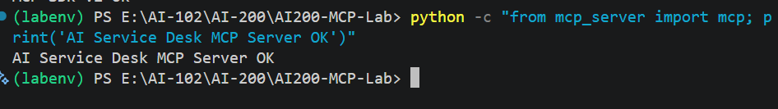

Step 8 — Tell VS Code About Your Server
Now we point VS Code at your server so Copilot knows it exists.
Create the file .vscode/mcp.json and add:
{
"servers": {
"ai-service-desk": {
"type": "stdio",
"command": "python",
"args": [
"${workspaceFolder}/mcp_server.py"
]
}
}
}
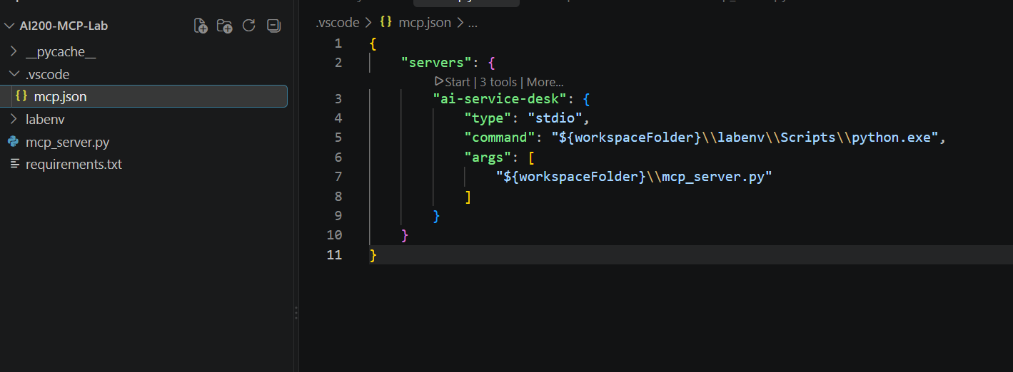
Why "stdio"? It just means VS Code talks to your Python script directly through input and output text — no web server or port needed.

Step 9 — Turn On Copilot Agent Mode
This is the moment your tools become visible to Copilot.
Open GitHub Copilot Chat in VS Code and select Agent mode. Then open the tools list.
You should see:
AI Service Desk
├── create_support_ticket
├── get_ticket_status
└── search_knowledge_base
If VS Code asks for permission, choose Allow in this Session.
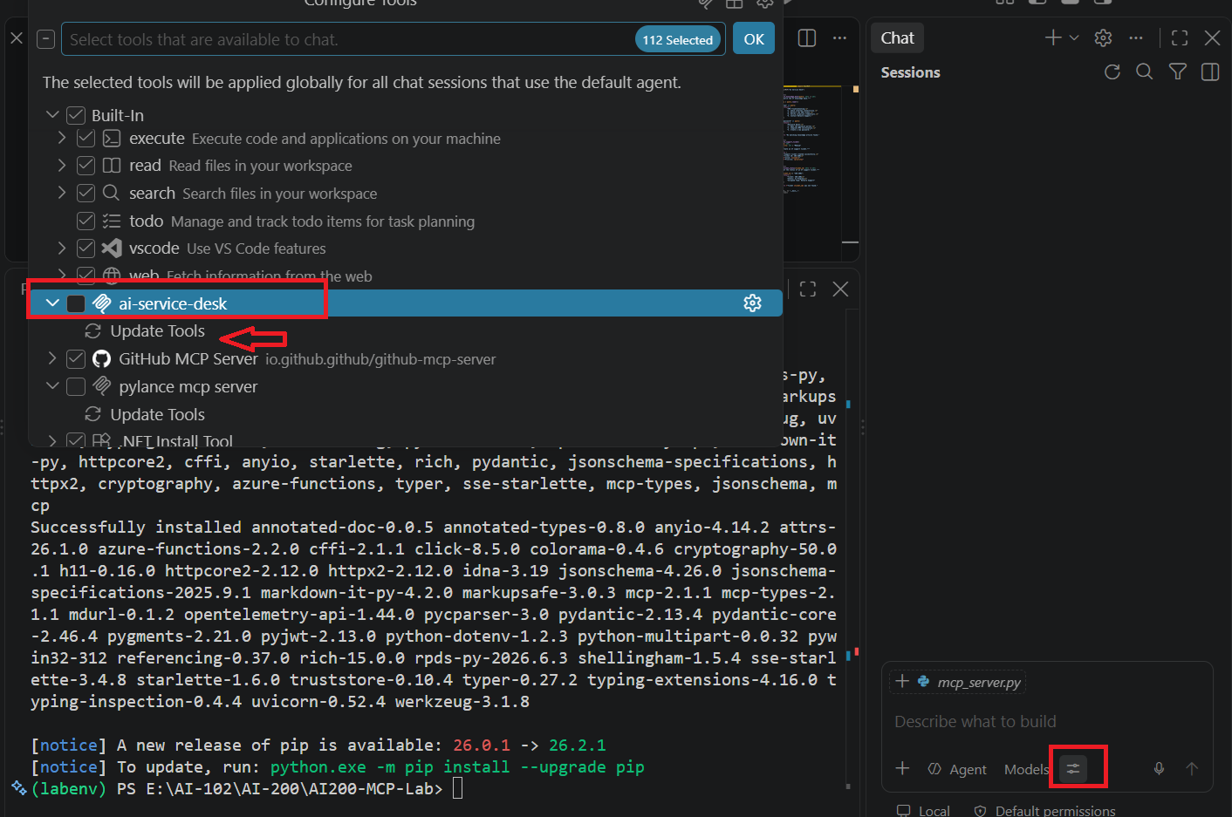

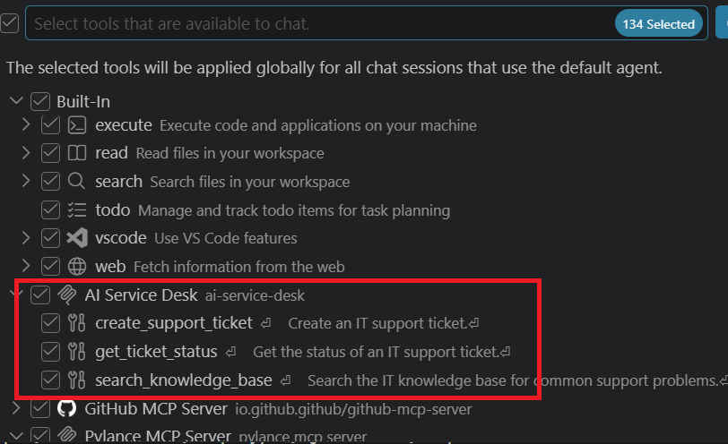

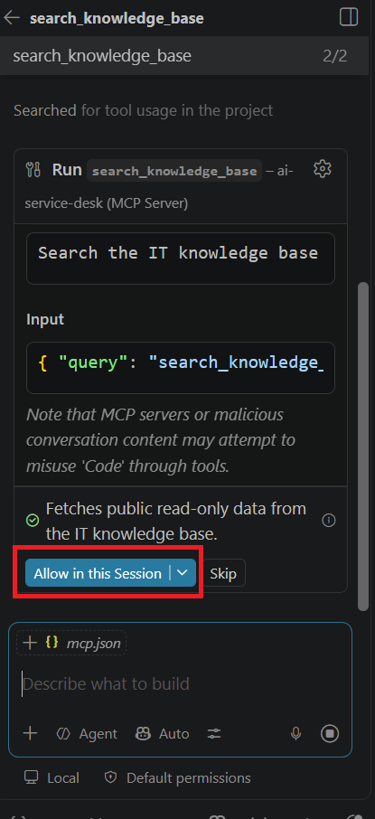

Step 10 — Try the Knowledge Base Tool
Time to test it with a real, plain-English question.
Type this into Copilot Chat:
My laptop cannot connect to the company VPN. Search the knowledge base for a solution.
Copilot should automatically use search_knowledge_base and return the VPN troubleshooting steps. This is the main moment of the lab — Copilot picking the right tool on its own.

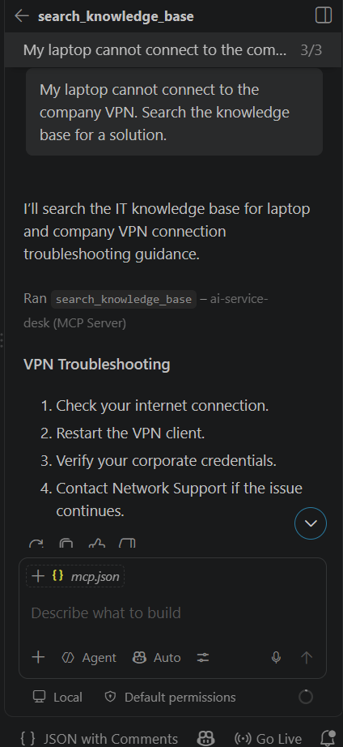

Step 11 — Try Checking a Ticket
Now ask Copilot to look something up for you.
Type:
Check the status of ticket INC-1001.
Copilot should use get_ticket_status and tell you it's In Progress with the Network Support team.

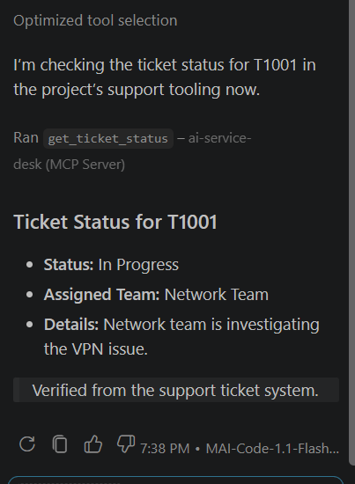

Step 12 — Try Creating a Ticket
Now let Copilot open a ticket for you.
Type:
Create a high priority support ticket because my company VPN is not working and I have an important customer meeting.
Copilot should use create_support_ticket and confirm the new ticket was created.
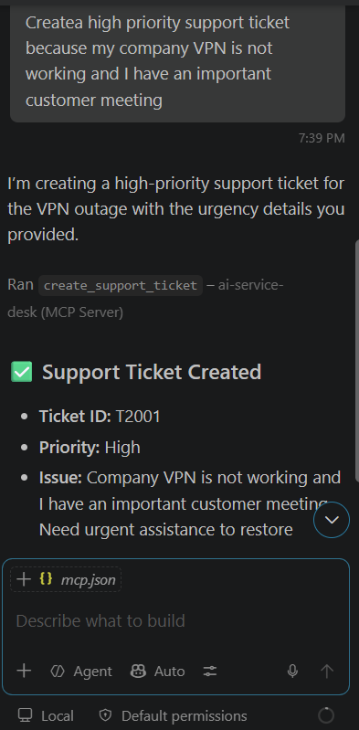

Step 13 — Put It All Together
This final test shows the real value of MCP: Copilot deciding, step by step, what to do.
Type:
My laptop cannot connect to the company VPN and I have an important customer meeting in 30 minutes. Search the knowledge base first. If there is no useful solution, create a high priority support ticket.
Copilot should search first, and only create a ticket if it needs to. That decision-making is the whole point of MCP.
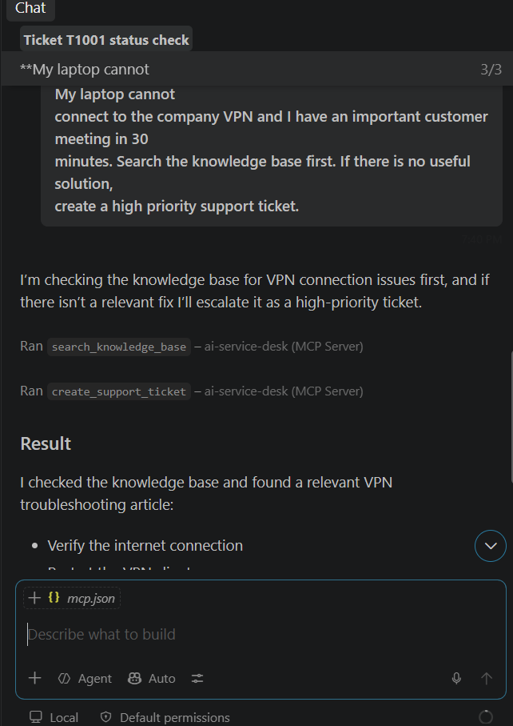

What You Just Built
Here's the core idea to remember: the AI model (Copilot) never touches your knowledge base or ticket system directly. Instead:
- Copilot decides which tool is needed
- MCP passes the request to that tool
- The tool runs and sends back a result
- Copilot turns that result into a plain-English answer
That hand-off is the entire idea behind MCP — it gives an AI model safe, structured access to real code and real data.

Final Checklist
Before you finish, confirm each of these is working:
Check | Done?
Python 3.12 installed | ✅
Virtual environment created and activated | ✅
mcp[cli] installed | ✅
MCPServer import works | ✅
mcp_server.py loads without errors | ✅
.vscode/mcp.json configured | ✅
"AI Service Desk" appears in Copilot's tool list | ✅
search_knowledge_base responds to a VPN question | ✅
get_ticket_status returns a ticket's status | ✅
create_support_ticket creates a new ticket | ✅

You're done!
If every box above is checked, you've successfully built and tested your first MCP server. You now know how to give an AI agent real, working tools.

